# **Git & GitHub Documentation**

### [**Lesson 2. Introduction to git and GitHub**](https://youtu.be/ulTs4vqOzyo)

1. git?
   * git is a version control software
   * It keep track of code changes
   * It helps to collaborate in a project
   * It is installed and maintained locally
   * It provides Command Line Interface (CLI)
   * Released in April 7, 2005
   * Developed by Linus Torvalds & Junio C Hamano
2. github?
   * GitHub is a hosting service where we can keep our git repositiory/folders
   * It is maintained on cloud/web
   * It provides Graphical User Interface (GUI)
   * Founded in 2008

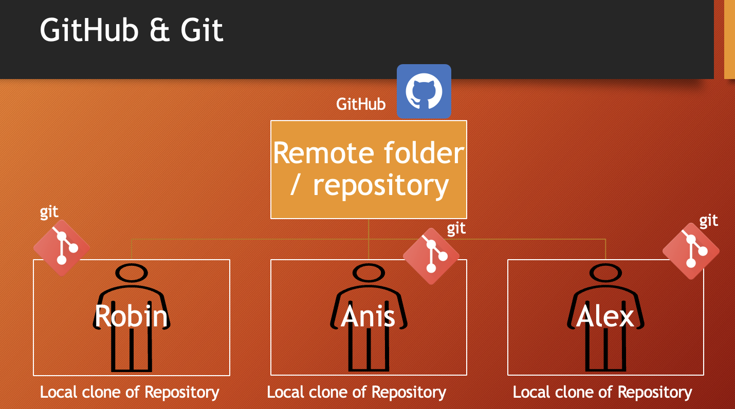

### [**Lesson 3. How to set git environment and configuration**](https://youtu.be/vj5-nkhTRbo)

* Download and install git on your pc: <https://git-scm.com/>
* check git version: open terminal or cmd then use the command git --version to find out whether git is installed or not. if git is installed it will return a version number of git.

git configuration

1. check all configuartion options: git config
2. set global user name and user email for all repository/git folders (if you want to set different username and email for different git repository then remove --global)
   * set global user name: git config --global user.name "anisul-islam"
   * set global user email: git config --global user.email "anisul2010s@yahoo.co.uk"
3. list all git configuration:
   * list all the configuration: git config --list
   * list user name: git config user.name
   * list user email: git config user.email
4. change global username & email
   * change global user name: git config --global user.name "PUT_NEW_USER_NAME_HERE"
   * change global user email: git config --global user.email "PUT_NEW_USER_EMAIL_HERE"

### [**Lesson 4. creating git repo and adding new files**](https://youtu.be/oa6viOCTEeM)

1. creating a git folder

ls -a : list all files inside of a directory  
mkdir DIRECTORY_NAME_HERE

cd DIRECTORY_NAME_HERE

git init

Example:

mkdir notes

cd notes

git init

ls -a

1. adding new files in git folder

git status : displays the state of the working directory and staging area  
ls -a

touch fileName.extension

open fileName.extension

git status

Example:

touch day1.txt

open day1.txt

write something inside the file

* Git is aware of the file but not added to our git repo
* Files in git repo can have 2 states – tracked (git knows and added to git repo), untracked (file in the working directory, but not added to the local repository)
* To make the file trackable stagging or adding is required

### [**Lesson 5. how to add files in staging area & remove files**](https://youtu.be/IDhgZX4esQQ)

1. adding files to stagging area:

* git add fileName add a file in staging area / index
* git add . add all files of directory to stagging area not subdirectory
* git add -A add all files of directory and subdirectory to stagging area
* git rm --cached fileName unstage a file from staging area
* git diff - checking the differences of a staged file
* git restore fileName - restore the file

### [**Lesson 6. practice-1**](https://youtu.be/jSj-GF-utls)

### [**Lesson 7. commit & uncommit**](https://youtu.be/gmBKbxKGcn8)

* git commit -m "message" move the file to local repository from stagging area
* git log check the commit history
* git reset --soft HEAD^ uncommit the commit in HEAD and move to staging area
* git reset HEAD^ uncommit the commit in HEAD and move to unstaging / working area
* git reset --hard HEAD^ uncommit the commit in HEAD and delete the commit completely with all the changes

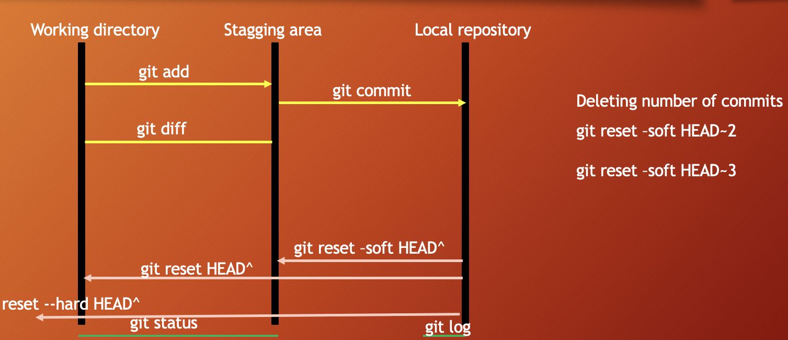

### [**Lesson 8. git HEAD and undo theory**](https://youtu.be/xUNsecljvog)

* git log --oneline
* git show
* git show HEAD^
* git show commit-id
* git checkout commit-id
* git checkout master

### [**Lesson 9. git HEAD and undo practical**](https://youtu.be/rEoeC-HBqws)

### [**Lesson 10. git revert**](https://github.com/anisul-Islam/github-documentation/blob/master)

### [**Lesson 11. git ignore**](https://youtu.be/CKla6oWTezM)

* create a .gitignore file and add the things you do not want to add in the stagging area
* Inside .gitignore we can keep secret files, hidden files, temporary files, log files
* secret.txt secret.txt will be ignored
* *.txt ignore all files with .txt extension
* !main.txt ignore all files with .txt extension without .main.txt
* test?.txt ignore all files like test1.txt test2.txt
* temp/ all the files in temp folders will be ignored

### [**Lesson 12. how to create github repository and commits**](https://github.com/anisul-Islam/github-documentation/blob/master)

* sign in to your github account
* create a git repo

### [**Lesson 13. README.md**](https://youtu.be/bl0-DTgh-mw)

* Everything you need to know about README.md is discussed in the video.
* 6 heading levels: number of hashes define heading levels. check the following examples:
  + # heading 1 level text is here
  + ## heading 2 level text is here
* bold syntax: __text goes here__
* italic syntax: _text goes here_
* italic syntax: _text goes here_
* strikethrouh syntax: ~this is~~
* single line code syntax: `` place code inside backticks
* multiple line code syntax: ``` place code inside three open and closing backticks
* multiple line code syntax: ```html for specific lanaguage use language name when starting; not closing
* for more please check the video by clicking the link given above

### [**Lesson 14. Connecting local repo to remote repo**](https://youtu.be/sLX2YWYpkAc)

* check remote connection: git remote or git remote -v
* git remote add name <REMOTE_URL> example: git remote add origin http://...

### [**Lesson 15. push and pull**](https://youtu.be/UXEoCfYwI1Q)

* push a branch git push -u origin branch_name
* push all branches git push --all
* pull from a repo: git pull which is equivalent to git fetch + git merge

### [**Lesson 16. branching and merging**](https://youtu.be/3k8Bq_usPsk)

* Branch is a new and separate branch of master/main repository
* create a branch git branch branch_name
* List branches git branch
* List all remote branches git branch -r
* List all local & remote branches git branch -a
* move to a branch git checkout branch_name
* create and move to a branch git checkout -b branch_name
* delete a branch: git branch -d branch_name

merge branches:  
 git checkout branchName

git merge branchName

* git log --oneline --all --graph

### [**Lesson 18. git and GitHub practice - 2**](https://youtu.be/IHVzseHh3Bo)

### [**Lesson 19. GitHub Issues**](https://youtu.be/E5HFlpx7QP4)

### [**Lesson 20. 2-way and 3-way merges**](https://github.com/anisul-Islam/github-documentation/blob/master)

* Reeference:
  + <https://www.tutorialspoint.com/what-is-a-fast-forward-merge-in-git>
  + <https://www.tutorialspoint.com/what-is-3-way-merge-or-merge-commit-in-git>
  + <https://medium.com/@koteswar.meesala/git-fast-forward-merge-vs-three-way-merge-8591434dd350>

### [**Lesson 21. Merge Conflicts**](https://github.com/anisul-Islam/github-documentation/blob/master)

* <https://www.tutorialspoint.com/what-is-merge-conflict-in-git-how-to-handle-merge-conflicts>